DAILY ASSESSMENT FORMAT

|  |  |  |  |
| --- | --- | --- | --- |
| Date: | 22nd July 2020 | Name: | Persis P |
| Course: | coursera | USN: | 4AL17EC069 |
| Topic: | Basic statistics | Semester & Section: | 6 & B |
| GitHub  Repository: |  |  |  |

SESSION DETAILS

Session images

Report:

Understanding statistics is essential to understand research in the social and

behavioural

sciences.

In this course you will learn the basics of statistics; not just how to calculate them, but also how

to evaluate them. This course will also pr

epare you for the next course in the specialization

-

the

course Inferential Statistics.

In the first part of the course we will discuss methods of descriptive statistics. You will learn what

cases and variables are and how you can compute measures of cent

ral tendency (mean, median

and mode) and dispersion (standard deviation and variance). Next, we discuss how to assess

relationships between variables, and we introduce the concepts correlation and regression.

The second part of the course is

concerned with the basics of probability: calculating probabilities,

probability distributions and sampling distributions. You need to know about these things in order

to understand how inferential statistics work.

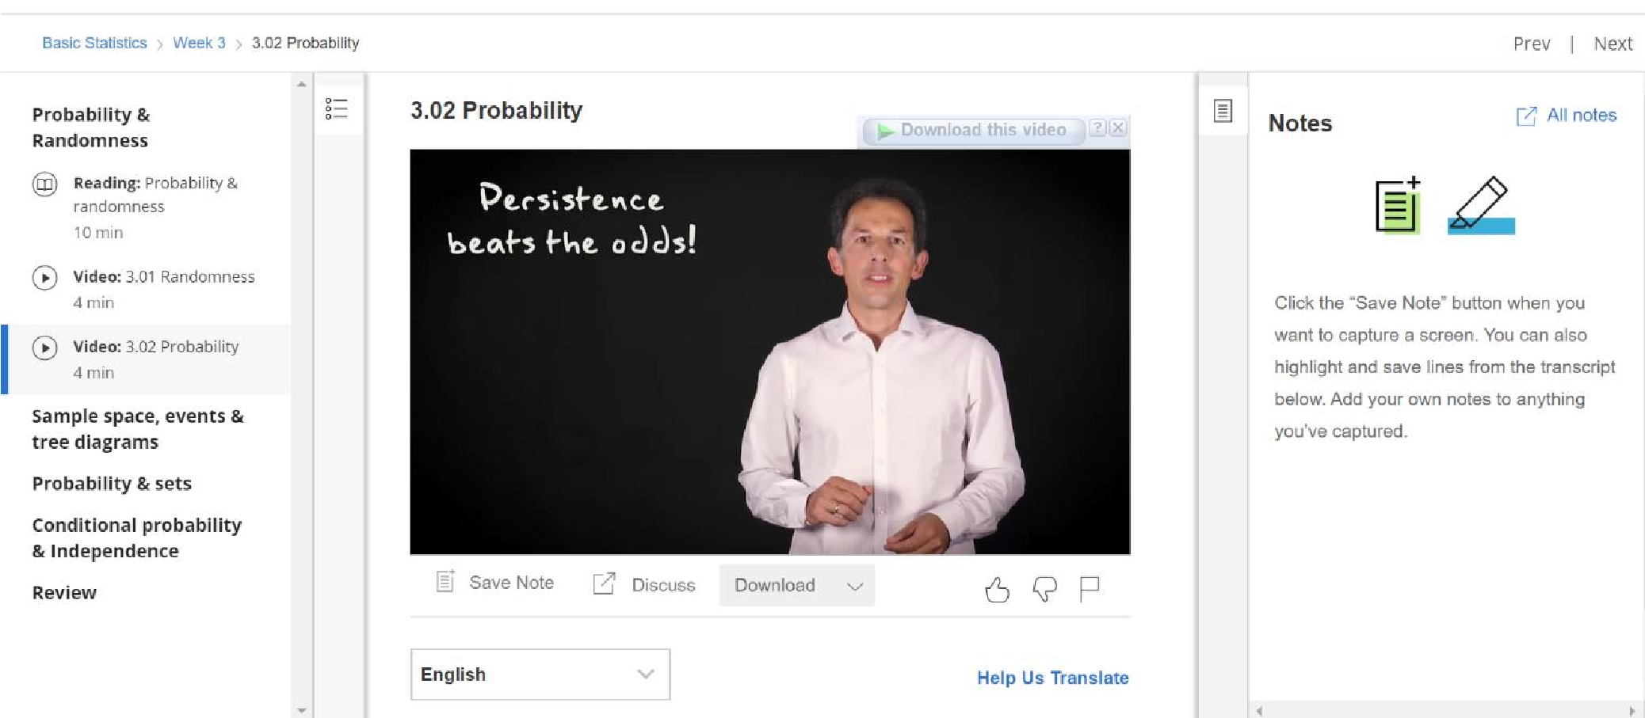

The third part of the course consists of an introduction to methods of inferential statistics - methods that help us decide whether the patterns we see in our data are strong enough to draw conclusions about the underlying population we are interested in. We will discuss confidence intervals and significance tests.

You will not only learn about all these statistical concepts; you will also be trained to calculate and generate these statistics yourself using freely available statistical software.

Before we can understand probability, we first have to understand another concept: randomness. The first video explains this concept. It also shows that even though randomness is everywhere around us, humans are nonetheless bad in assessing it.

|  |  |
| --- | --- |
| Session images | SESSION DETAILS |

Once we understand randomness, we can define probability as a way to quantify randomness. The second video explains how this quantification can be accomplished by experiments which record the relative frequency that certain events of interest occur. It follows that probabilities are always larger or equal to zero and smaller or equal to one; and also, that the sum of the probabilities for all possible events equals one. Due to the very nature of random events, the experiments may have to continue for a while before the relative frequencies represent the probabilities accurately, but the law of large numbers dictates that it will do so eventually.

DAILY ASSESSMENT FORMAT

|  |  |  |  |
| --- | --- | --- | --- |
| Date: | 22nd July 2020 | Name: | Persis P |
| Course: | workshop | USN: | 4AL17EC069 |
| Topic: | How to develop Pythonic coding rather than Python coding | Semester & Section: | 6 & B |
| GitHub  Repository: |  |  |  |

Report:

A tuple is a collection of objects which ordered and immutable. Tuples are sequences, just like

lists. The

differences between tuples and lists are, the tuples cannot be changed unlike lists and

tuples use parentheses, whereas lists use square brackets.

Tuples are immutable which means you cannot update or change the values of tuple elements.

You are able to ta

ke portions of existing tuples to create new tuples

The most basic data structure in Python is the

sequence. Each element of a sequence is assigned a

number

-

its position or index. The first index is zero, the second index is one, and so forth.

Python has

six built

-

in types of sequences, but the most common ones are lists and tuples, which

we would see in this tutorial.

There are certain things you can do with all sequence types. These operations include indexing,

slicing, adding, multiplying, and checking

for membership. In addition, Python has built

-

in functions

for finding the length of a sequence and for finding its largest and smallest elements.

